**Storing variables**

Dim is used to store scalar variables. IT is used to declare a variable name  
ex Dim a  
a=10

Set is used to store an Object.

Ex Set HomePage=Browser(“name:=Title”).Page(“title:=Order Manage”)

NOTE: Here HomePage also needs to be mentioned in Dim and declare there.

**Static Vs Dynamic**

Sometimes UFT is unable to recognize the elements when static descriptive program is used as follows

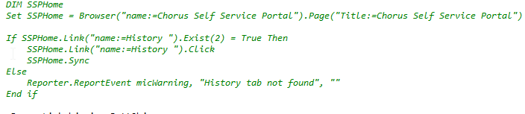

So as an alternative we can dynamic descriptive programming as follows.

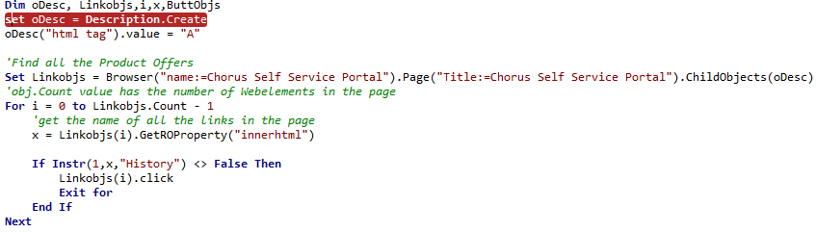

* Option Explicit is used so that UFT throws errors in case a variable is not defined using Dim

**Recognizing object with multiple parameters**



**Escape Characters**

Sometimes qtp wont be able to recognize objects.

e.g

**Set** OdescRescheduleBSFormLink=**Description**.Create  
OdescRescheduleBSFormLink("micclass").value="Link"  
OdescRescheduleBSFormLink("name").value="Automated Service Order Modification(BS)"

Since the above “name” value contains brackets “()” it thinks of it as a reg ex.

So escape character \ is used like so.

OdescRescheduleBSFormLink("name").value="Automated Service Order Modification\(BS\)"

Similarly if a ” was to be a part of the value then we need to use two “” as an escape character.

Eg given in below link

<http://stackoverflow.com/questions/2942554/adding-quotes-to-a-string-in-vbscript>

**Failing a Test on micfail**

When a mic fail is encountered, qtp continues and finishes the method, before failing, and doesn’t terminate on the failure itself.

To fail use ExitTest after micFail

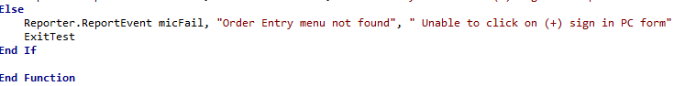

**QTP Error Handling and various other stuff**

<https://www.tutorialspoint.com/qtp/qtp_error_handling.htm>

**Exist() methods**

The method is used check if an object exists or not.

By specifying a numeric value in the method like Exist(2), it tries to search for the method for 2 seconds.

By default if no value is provided, it searches for whatever is set up in the settings of UFT which is usually 20s.

**4 hidden methods in UFT**

* Highlight
* TestArg
* Reporter
* Mercury.DeviceReplay

<https://www.joecolantonio.com/2014/11/06/revealed-four-secret-functions-hidden-in-qtp-and-uft/>

**Keyboard hits and Mouse Clicks**

<https://www.joecolantonio.com/2010/09/23/3-ways-to-use-keyboard-input-in-quicktest-professional-type-sendkeys-and-device-replay/>

**Some Performance Tips**

<https://www.joecolantonio.com/2010/09/02/eight-performance-tips-to-help-optimize-your-qtp-code/>